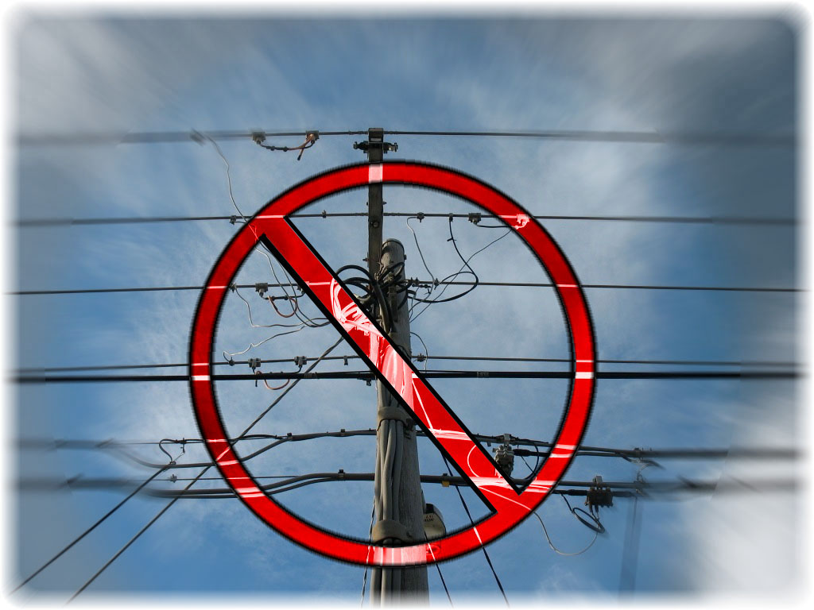

e-mail: kelso@internode.on.net
7 September 2011

Manager, Carrier Powers and Immunities
NBN Implementation Division
Department of Broadband, Communications and the Digital Economy
e-mail: LIFD@dbcde.gov.au

Possible changes to the Telecommunications (Low-impact Facilities) Determination 1997 and Telecommunications Regulations 2001 to facilitate the rollout of the National Broadband Network (NBN)

The following comments are submitted relating to possible changes to the Telecommunications (Low-impact Facilities) Determination 1997 and Telecommunications Regulations 2001 to facilitate the rollout of the National Broadband Network (NBN). Although the Attachment summarises previous writings on the topic that will be drawn upon, this submission also introduces arguments responding to new issues raised by the Department’s ‘Invitation to Comment’.

Executive Summary

1. It is unconscionable for the federal government to take away state, territory and local government planning powers intended to benefit the public that expects government to exercise a duty of care by ensuring the NBN will at all times deliver lifeline communications.

2. Overhead construction of the access network component of the NBN can seriously degrade service reliability to those affected. Australians should be very worried about ‘investing in nation-building infrastructure needed for tomorrow’ that is held up by electricity poles which tend to rot, get hit by errant road vehicles or burn in bushfires. Such an outcome outstandingly fails the basic premise of creating 21st century broadband as a building block of Australia’s future digital economy and in no way can be said to be ‘world class’.

3. The Australia-wide roll out of overhead cabling by NBN Co will be an affront to the public that desires to protect the local amenity by ensuring that, over time, as much as possible of the present overhead utility infrastructure will be put underground.

4. The proposal to grant NBN Co the additional powers and immunities to extensively roll out overhead optical fibre cabling, without being subject to local planning powers, is not only technologically backward and politically deceitful, it is based on a dishonest presentation of the facts, viz.

- The claimed benefits of overhead construction cannot be sustained using either short or long-term economic or social justifications;
- The proposed extent of overhead construction, said by NBN Co to be 25 per cent, will actually be noticeably greater – more like 30 per cent, but with 100 per cent coverage occurring in many localities;
- Neither the government nor NBN Co have seriously considered the alternative of only 10 per cent overhead construction, despite quantification in the NBN Co corporate plan revealing that the total project cost would nevertheless come under the long-stated budget estimate;
- NBN Co are under no obligation to reveal the criteria they adopt to decide which customers and which localities will win the ‘lucky dip’ by having overhead construction, nor are they under any obligation to consult with those so adversely affected;
- NBN Co are under no obligation to reveal the amount of annual attachment fees they are to pay to the owners of the electricity poles they will be exploiting;
- Practical installation of overhead optical fibre cabling throughout Australia’s electricity distribution network results in the NBN cabling being just as obtrusive as the earlier generation HFC network (which is may still remain in situ) and further compounds the visual eyesore.

5. The Telecommunications (Low-impact Facilities) Determination 1997 should rather be amended to exclude overhead cabling not compliant with deployment criteria that protect community welfare.

Discussion

The following discussion expands on why the above conclusions are justified. Since a number of the issues raised are overlapping, a one-to-one correlation may not always be evident.

Overhead construction of the NBN does not constitute ‘nation-building infrastructure of the future’ and in no way can be said to be ‘world class’

Since the mid-1970s, Australia's electricity companies resolved to underground most new electricity distribution services in new developments and this outcome has been enshrined in state and local planning schemes. For decades prior, the Postmaster General's Department, later to become Telecom Australia and then Telstra as the monopoly provider of telephony services, adopted the practice of undergrounding its telecommunications infrastructure in almost all urbanised areas.

This national consensus was only broken with the introduction of competitive infrastructure in providing pay television (during 1995/96) that resulted in significant areas of our mainland capital cities being criss-crossed with at least one and often two overhead networks of hybrid fibre-coaxial (HFC) cables. However the NBN is to be a government-mandated monopoly that replaces Telstra's entire copper-based customer access network; it is critical to note that the NBN will become the infrastructure provider of last resort to carry lifeline telecommunication services.

As a telecommunications-carrying medium, optical fibre is unsurpassed in its ability to carry ever-increasing amounts of data as technical standards and interfaces are upgraded. In that respect, it is often regarded as being ‘future proof’. However, attaching optical fibre cabling to electricity or utility poles - infrastructure of an earlier century – is a highly retrograde step. It’s akin to building a house on beach sand, in full knowledge that the next storm may wash or blow it away! Why would any sensible person do this?

A 90 per cent undergrounded NBN is quite affordable as the NBN Co corporate plan states it would meet the long-stated budget estimate of $43 billion

The NBN Co Corporate Plan summary issued December 2009 reveals that 25 per cent of premises would be served by overhead deployment in the local network, representing 31,000km of cabling. Furthermore, the Plan reveals that if (for example) limited access to overhead right-of-way corridors became a constraint such that overhead deployment was instead constrained to 10 per cent of brownfields premises, then NBN projected returns would reduce from 7.0 per cent to 6.8 per cent and total/peak funding would increase by $1.8 billion (with government equity increasing by $1.3 billion). This amount compares with a total estimated funding requirement of $40.9 billion.

In other words, the NBN Co Corporate Plan reveals the total funding requirement to be $40.9 billion with 75 per cent undergrounded, versus $42.7 billion with 90 per cent undergrounded. The latter figure almost exactly equates to the long-stated budget estimate of $43 billion capital outlay when the NBN project was first launched.

Expressed in more pedestrian terms, the impact of an additional $1.8 billion (being the cost of the undergrounding 90 per cent, instead of 75 per cent) amounts to a once-off sum of about $59 per person throughout Australia - or perhaps 17 cappuccinos in the lifetime of each person.

The cost of a 100 per cent undergrounded NBN local network is not revealed in the NBN Corporate Plan, but they have no incentive to produce an affordable outcome for this scenario.

There is no basis for the claim, made in the ‘Invitation to Comment’, that “the significant long-term economic and social benefits of access to high-speed broadband will deliver justify consideration of these changes”

The Department of Finance and Deregulation requires cost-benefit analyses to take a long-term view, a community-wide perspective and incorporate all relevant costs and benefits. However, as the Minister has steadfastly refused to submit the National Broadband Network to any cost-benefit analysis, there is no substantive basis for claiming that incorporating 25 per cent of overhead construction will result in any significant long-term benefits.

It is beyond question that, compared to underground deployment, overhead construction of the NBN will be faster to roll out and less expensive. The cut-over of the first Tasmanian services, all delivered overhead, was clearly stage-managed to coincide with the 2010 federal election — so the speed of roll-out appears to be politically contrived. If a 90 per cent underground roll-out takes, say, another six months to complete, or a 75 per cent underground roll-out takes perhaps another eighteen months to complete, any loss of long-term benefit from this delayed availability of faster broadband would be miniscule – assuming it could be quantified with any certainty. Regarding the additional expenditure, it has already been explained how the impact of a 90 per cent undergrounded network has a minor impact on the overall capital outlay and projected return.

Overhead construction indisputably leads to many adverse consequences

(i) All overhead cables (and electricity lines) naturally sag in a catenary fashion such that the lowest point occurs mid-span. Road traffic regulations require that this mid-span clearance of the lowest cable above the crown of the road must be no less than about 5 metres. Where this clearance is inadequate, high road vehicles are likely to snag the cable - resulting in broken cables, broken lines and interruption to electricity and communication services.

Maintaining the necessary minimum clearance becomes more difficult when the road slopes longitudinally or laterally (i.e. one side is higher than the other) and when, over time, poles bend due to their age and soil movement. At road junctions the clearance problem may be further exacerbated due to the extra number of cables converging at one location and allowance for street lights, stay wires, etc. Lead-ins to homes present a clearance problem for extra overhead cables, particularly when they pass over driveways (including those of neighbouring properties) and more so when the house is on the low side of a road and the electricity poles are on the opposite and higher side. High vehicles such as Council garbage trucks and furniture removal vans accessing properties are more likely to collect the lowest hanging cable.

All state road traffic and safety authorities are well aware of the regular occurrence of electricity poles being hit by vehicles, with electricity lines being brought down or even the poles being destroyed.

(ii) Severe storms regularly bring down trees on top of electricity lines and any telecommunications cables – particularly in rural areas and in the more tropical parts of Australia. Due to the known occurrence of damaging cyclones, the Townsville City Council’s strong preference was that the NBN be deployed underground – yet NBN Co appointed the local electricity distributor, the direct beneficiary of pole attachment fees, as the contractor for the fibre roll-out there. Cyclone Yasi promptly brought down poles!

(iii) Recent Queensland floods and inundation graphically demonstrated how water-borne debris can readily destroy overhead utility construction.

(iv) Recent Victorian and New South Wales bush fires dramatically illustrated the vulnerability of all above-ground infrastructure, whether electricity or telecommunications, and conversely the protection offered by below-ground infrastructure which escaped destruction. The compound failure of overhead electricity, telephone and Internet services totally isolated affected residents; within a day or so even mobile phone batteries were exhausted.

Where access cabling for the NBN is installed overhead along local roads, it causes old electricity poles to be unnecessarily upgraded, worsens the visual environment, reduces the clearance above road and driveway levels, and totally negates any remaining opportunity to retrospectively underground overhead cables and lines throughout Australia. Furthermore, every length of NBN aerial cabling shared by a number of customers may result in reduced service reliability for those customers due to the increased likelihood of an upstream cable being damaged by high vehicles, falling trees, bush fires or the supporting poles being hit by errant vehicles. Such causes of service unreliability remain regardless of whether the optical fibre cable deployed with the NBN is non-metallic compared to that of any previously installed HFC networks.

This prognosis applies where any NBN overhead cabling is the first non-electricity asset to be pole-attached and is even more applicable where one or two HFC pay television cables already exist. Not only can NBN access cabling suffer degraded service reliability in its own right once constructed overhead, no broadband service is possible without reliable electricity to customer premises. With both NBN and electricity services supported on the same pole route, the incidence of telephony and Internet service outages having adverse lifeline consequences is further magnified. NBN Co, a company wholly owned by the federal government, has a duty of care in this regard – particularly since it service continuity during major natural disasters will be reliant on battery back-up.

Retention of the Low-impact Facilities planning powers gives local communities a voice in responding to these adverse consequences.

Despite optical fibre cable being non-metallic, other considerations cause it not to be installed inconspicuously amongst existing electricity wires

In theory, optical fibre cabling could be safely installed immediately alongside electricity wires attached to pole cross arms and thereby become less visible and more protected from external interference. However, it appears that practical considerations related to installation and maintenance, let alone the standard of training required by personnel, result in an entirely different outcome. Casual observation indicates that even electricity distribution companies intentionally install their own optical fibre cabling separate from the electricity lines; where electricity company fibre cabling has been installed atop poles it appears to be only of a long-distance nature between sub-stations and is not accessed on a pole-by-pole basis for local distribution.

The very first NBN roll-out in Scottsdale, Tasmania was deployed overhead since early 2010 and this practice has continued ever since. Clearly, on that occasion Aurora Energy reckoned that technical and service delivery standards of its electricity distribution operations would be adversely affected if the fibre-to-the-home network were to be installed more closely to the electricity assets – regardless of the fact that such a modern day network is non-metallic. After all, the NBN network is foreign to the business of the electricity distributor. Visual inspection suggests that a separation of one to one-and-a half metres (the ‘LV exclusion zone’) has been stipulated for the safety of personnel involved and/or to ensure minimal impact on electricity service reliability. Nothing has changed with subsequent NBN overhead roll-outs elsewhere in Australia – they have been just as conspicuous as overhead HFC cabling.

Retention of the Low-impact Facilities planning powers gives local communities a voice in responding to the continuation of visually obtrusive overhead telecommunications infrastructure.

The declared amount of 25 per cent overhead construction will in reality be seen to be more like 30 per cent

This is a most appropriate question to ask since the NBN Co Corporate Plan states that 25 per cent of the local access network roll-out will be overhead. NBN Co has clearly stated (and it would be gross stupidity otherwise) that they will not be creating new utility poles where none exist. So for starters we can rule out NBN overhead cabling where existing electricity lines are underground. Not surprisingly, Telstra’s cables are universally underground where electricity lines are underground. Electricity (and hence also telecommunications) lines are typically underground in most new residential and many new industrial developments throughout Australia since about 1985, though no doubt there are instances where this didn’t happen in a few areas due to local circumstances. Electricity lines are also increasingly undergrounded in many CBD and near-CBD areas, certain areas of historical significance and where deemed necessary for operational reasons.

The Report of the Putting Cables Underground Working Group revealed that in 1998, of about 5.6 million dwellings in the whole of the electricity distributor areas surveyed, about 0.6 million already had underground electricity. That is, 89 per cent were served with overhead electricity lines. Starting with that figure, 25 / 0.89 equals 28 per cent; since the 25 per cent of NBN construction that is to be overhead can only occur where existing electricity lines are overhead, the visual impact will actually be more like 28 per cent!

However since 1998, both the 5.6 and 0.6 figures would have risen but at what rate for each? On the probable basis the rate of growth of inner city apartments has exceeded the rate of growth in outer suburban single dwellings (where the infrastructure is underground) but that the former has resulted in densification whereby more dwellings have been served by the same street utility infrastructure, it is arguable that, in the absence of better data, the imputed 28 per cent figure could nowadays be closer to 30 per cent.

Whole swathes of regional towns and metropolitan suburbs will be disadvantaged by winning the ‘lucky dip’ of NBN overhead construction, where the effective extent will be seen to be closer to 100 per cent!

It is understood that NBN Co strongly prefer their main route optical fibre cabling in built-up areas to be underground so as to gain maximum protection from mechanical interference. NBN Co has at times stated that NBN cabling may be constructed overhead wherever existing Telstra lines are overhead – an argument which is not only flawed but a practice that seems not to have been followed so far (for example, by personal observation in Armidale, NSW). However what is now abundantly obvious is that those streets to be ‘blessed’ with overhead construction will disproportionately occur where property frontages are larger than usual, where Telstra’s pipe network is of smaller diameter and where the terrain is rockier than usual. Many of these occurrences happen to arise on urban fringes - which just also happen to be more exposed to damage from bushfires and/or storm-driven debris, not to mention being more poorly served by emergency and health services that those communities will call upon in times of natural disasters.

The practical result of the 25 (or 28 or 30?) per cent of NBN overhead construction will not be that one in every four houses in a given street will be served overhead, or that one street in every four in a given suburb will be served overhead. Instead, the much more likely outcome will be that NBN Co will deploy overhead cabling in major portions of certain suburbs, whole suburbs and even whole towns. In other words, the effective extent of overhead NBN construction in these areas will be seen to be closer to 100 per cent!

Retention of the Low-impact Facilities planning powers gives local communities a voice in responding to the adverse impact of plans for widespread overhead construction.

Rational and transparent criteria for permitted deployment of overhead NBN cabling can be developed that should garner community support

It is totally unacceptable for a government-mandated monopoly to decree when and where it will deploy nationally significant infrastructure that detracts from community welfare and to do so behind a veil of secrecy. Rational criteria for permitted deployment of overhead NBN cabling (intended to be applied within the planning envelope of preferably just a maximum of 10 per cent of total roll-out for the local access network) could include the following:

- No more than, say, five per cent of the trees along the pole route need to be pruned or removed to facilitate the overhead cabling roll-out;
- No trees of significance are adversely affected;
- There is no heritage planning overlay applicable;
- The relevant local emergency authority can certify that the locality does not have a recent history of utility infrastructure being damaged by severe storms, bush fires or inundation;
- The relevant traffic accident authority can certify that the road does not have a recent history of vehicle accidents resulting in poles being brought down;
- No relevant state, territory and local governments, or electricity utilities, have plans to put the current infrastructure underground within the next 25 years.

The Telecommunications (Low-impact Facilities) Determination 1997 should be amended to exclude overhead cabling not compliant with such deployment criteria.

Please do not hesitate to contact me should you have any further queries.

Yours sincerely,

Ross Kelso, PhD
Attachment

Previous Writings Relating to the Inappropriateness of Aerial/Overhead Cabling Deployment of the National Broadband Network

3 June 2009 - Submission to the Department in response to the discussion paper ‘National Broadband Network: Regulatory Reform for 21st Century Broadband’ in which Issue 2 concluded:

Aerial construction of the access network component of the NBN will seriously degrade service reliability; a truly nation-building alternative would be to underground all aerial utility construction – with particular impact on electricity distribution lines. There are grounds to believe that this could be achieved for a broadly similar financial outlay if appropriate economies of scale and novel approaches are exploited. It cannot be in the public interest for the Telecommunications (Low-impact facilities) Determination 1997 to be amended as defining NBN cabling of ‘low impact’ as long as the alternative regulatory approaches remain untested.

http://www.dbcde.gov.au/__data/assets/pdf_file/0007/115387/Ross_Kelso.pdf

11 August 2009 - Submission number 94 to the Senate Select Committee on the National Broadband Network which concluded, in part:

Aerial construction of the access network component of the National Broadband Network will seriously degrade service reliability. Australians should be very worried about ‘investing in nation-building infrastructure needed for tomorrow’ that is held up by rotting electricity poles. Such an outcome outstandingly fails the basic premise of creating 21st century broadband as a building block of Australia’s future digital economy.

http://www.aph.gov.au/Senate/committee/broadband_ctte/submissions_from_april_2009/sub94.pdf

5 April 2010 - Submission number 124 to the Senate Select Committee on the National Broadband Network which concluded, in part:

Since the serious problems arising from aerial construction of the National Broadband Network were first raised towards the latter part of 2009, NBN Tasmania and NBN Co have shown a wilful disregard of the adverse impact on broadband service reliability and visual amenity throughout Australia. Such an approach is totally incompatible with any pretence of constituting a nation-building investment.

http://www.aph.gov.au/Senate/committee/broadband_ctte/submissions_from_march_2010/sub124.pdf

Attachment (continued)

A 2010 paper published in Volume 60, Number 3 of the Telecommunications Journal of Australia titled “Testing the NBN vision: Can aerial construction truly deliver 'a historic nation-building investment focussed on Australia's long-term national interest'?” which concluded, in part:

Australians should be very worried about investing in nation-building infrastructure held up by electricity poles which tend to rot, get hit by errant road vehicles or burn in bushfires. Such an outcome outstandingly fails the basic notion of creating 21st century broadband as a building block of Australia's future digital economy.

Whilst the federal government's announced roll-out of a National Broadband Network represents a truly visionary national policy, it will be severely blighted if any significant extent of the access infrastructure is to be aerially constructed. Now is the time for the federal government to instead adopt a truly inspirational vision for Australia by issuing a revised policy that results in the NBN to be installed fully underground along with the retrospective undergrounding of all existing aerial electricity lines.

http://journals.sfu.ca/tja/index.php/tja/article/view/21/html

2 May 2011 - An article in The Australian newspaper (“Cables ‘at risk’ from fires, floods”) warning that the federal government's plans to connect a quarter of the National Broadband Network via exposed overhead cables will place communities at increased risk from bushfires, floods and cyclones; this editorialised article noted in part:

Submissions to the 2009 Victorian bushfires royal commission into the Black Saturday fires that killed 173 people revealed many residents were heavily dependent on the internet for updates.

The commission also found last year that a loss of power and telecommunications "hindered relief efforts and interfered with communication".

Dr Kelso, who is also a director of the technology consumer group the Australian Communications Consumer Action Network, said the problem was compounded because overhead cables would likely be predominantly used in small towns and outer urban areas, which are prone to bushfires.

Other recent disasters, such as the Queensland floods in January and Cyclone Yasi in February, have also highlighted the vulnerability of Australia's overhead communications and electricity infrastructure.

http://www.theaustralian.com.au/news/nation/cables-at-risk-from-fires-floods/story-e6frg6nf-1226047988132

